
A12
Sreenidhi Institute of Science and Technology
(An Autonomous Institution)
Code No: 3F302
B. TECH. II-Year I-Semester Examinations, December 2015 (Supplementary)
MATHEMATICAL FOUNDATIONS OF COMPUTER SCIENCE (CSE & IT)

Time: 3 Hours Max. Marks: 70

Note: No additional answer sheets will be provided.

Part - A
Max.Marks:20

Answer all QUESTIONS. EACH QUESTION CARRIES 2 MARKS.

- Define Well Formed Formulas( WFF).
- Define Free Variable.
- Define Partition.
- Define subgroup.
- Define binary Tree.
- Define planar.
- Define function.
- Define Coset.
- Define homomorphism.
- Define spanning tree.
Part – B
Max.Marks:50

ANSWER ANY FIVE QUESTIONS. EACH QUESTION CARRIES 10 MARKS.

- Explain about
a) Principal Conjunctive Normal Forms (PCNF)
b) Inference rules with a suitable examples.

- Find an explicit formula for the sequence defined by the recurrence relation
a_{n} = 5a_{n-1} + 3 with initial condition a₁ = 3.

- Let A = {1, 2, 3, 4, 5} and R = {(x – y) | (x – y)² ∈ A}.
a) List all the elements of R.
b) Draw the Digraph of R.

- Explain about homomorphism of semigroups and monoids giving an example each.

- Find a minimal spanning tree for the connected graph below using Kruskal’s algorithm.
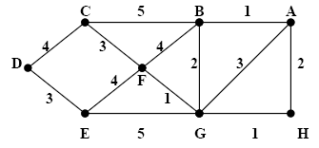

6. a) Give the Euler circuit, by giving the edges visited in the sequence, for the graph represented below, beginning at C.
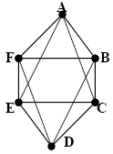
b) Give the Hamiltonian circuit, by giving the edges visited in the sequence, for the graph represented below, beginning at d.
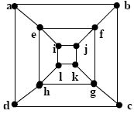

7. Explain about
a) Properties of Lattices and (6M)
b) Quantifiers (4M)

8. Explain about
a) Multigraphs and (4M)
b) Algebraic Systems with suitable examples. (6M)

-- 00 -- 00 --

